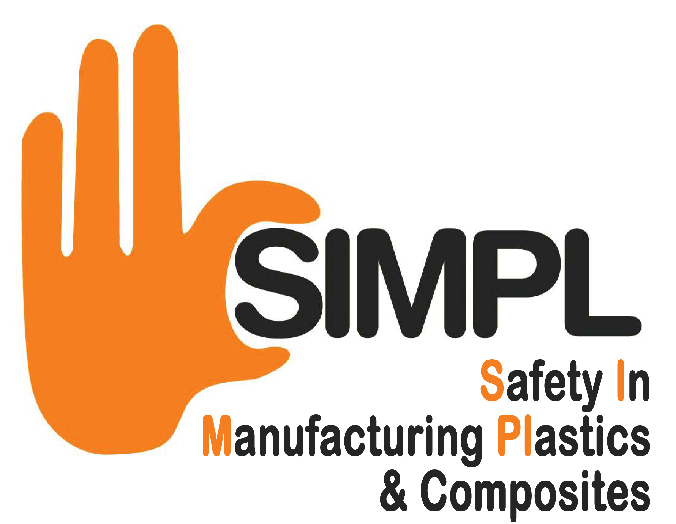

CEO SIMPLC Pledge

SIMPLC strategic health and safety targets for plastic industries 2022 - 2025

Our Pledge

On behalf of __________________________ I pledge our support for the health and safety improvement targets set out in SIMPLC’s strategic direction statement “Safety in Manufacturing Plastics and Composites 2022 to 2025”.
I commit the company to working to help our industry to achieve these targets. The targets we aim to achieve will be in line with our industry sector action plan. We shall do this by taking the following action:

Leadership
We will develop visible, felt, leadership in our company by designating a Director responsible for health and safety. They will establish targets for improvements in health and safety culture, personally monitor those targets, allocate resources to achieve targets and lead by example. We will empower our managers and supervisors to lead their areas of the workforce to help our organisation to achieve the company’s health and safety targets.

Management systems
We will develop and implement a health and safety management system that is appropriate to the size of our organisation and nature of our business. The health and safety management system will establish arrangements for formulating policy, planning, implementation, monitoring and review.

Workforce involvement
We will engage with our workforce and consult with them on all matters of health and safety. We will establish health and safety committees and communication arrangements for the purposes of health and safety.

Risk deduction
We will produce a company action plan to identify what our biggest health and safety risks are through the process of risk assessment. We will then identify and implement key actions to reduce the most significant risks within our workplace.

Accident reduction
We will put in place systems to record accident information (whether reportable or not). We will investigate accidents to identify root causes and monitor trends of accidents in our company. We will review this information and within the company health and safety action plan identify necessary steps to reduce accidents in our workplace.

To enable SIMPLC to evaluate improvements in industry performance over the next 3 years, I shall ensure that brief progress summaries are sent to our trade association, along with accident statistic report at 12 monthly intervals. This summary will be combined with other pledge signatories to keep SIMPLC informed of our industry’s overall progress towards achieving these important targets.

Signed
Name
Position
Date
I DO/ DO NOT (please delete as appropriate) give my consent to display our company name on the plastics part of the HSE website, Trade Associations web sites and in other media coverage to show to a wider audience our commitment to the SIMPLC strategy 2018-2021.

Please return this form to Composites UK, Audley House, Northbridge Road, Berkhamsted, HP4 1EH or email: info@compositesuk.co.uk

